Model SOP

Standard Operating Procedure

Name of the facility / activity : Therapeutic Plasma Exchange (TPE)

SOP no. | Effective Date | Pages | Prepared by | Authorised by
7.3 | 27-11-2000 | 23
Version | Review Period | Date of Review | Reviewed by | Number of copies
VI | 2 years | 01-01-2015 |  | 10
LOCATION : Ward/ Intensive Care Unit
SUBJECT : Apheresis
FUNCTION : Selective removal of plasma by cell separator machine for Therapeutic
purpose (Haemonetics MCS +)
DISTRIBUTION: Medical officer
Master File

- SCOPE & APPLICATION:
The selective separation and removal of plasma from withdrawn blood and the remainder of the blood then being retransfused with replacement fluids such as albumin FFP or balanced electrolyte solution into the patients through cell separator is called Therapeutic Plasma Exchange. This standard operating procedure applies to apheresis procedure using the haemonetics cell separator MCS Plus machine for TPE. TPE protocol combines optimal flexibility with the accuracy and convenience of automated volume accounting for the collected plasma and one substitution fluid.

- RESPONSIBILITY:
It is the responsibility of the Medical Officer and trained Staff Nurse and Technicians to perform the procedure along with resident doctor / doctor incharge of the patient either in the ICU or designated ward.

- MATERIAL REQUIRED
- Equipment and Material
- Haemonetics Cell Separator Machine
- MCS + TPE Kit (Haemonetics)
- TPE Protocol card
- BP instrument
- Stethoscope
- Tube Sealer
- Emesis Pan / Urinal
- Double lumen catheter (large bore – dialysis type)
- Reagents and solutions
- An adequate quantity of Anti coagulant solution
- Substitution fluid as per requirement
- Spirit
- Cotton swab
- Band Aid
- Emergency injection and drugs

- PROCEDURE:
The operator’s manual for the haemonetics cell separator and the direction for use with the apheresis kit should be followed at all times.
- Patient’s Assessment
The patient is evaluated as per the diagnosis and category of indication as per AABB guidelines for apheresis established. The patients lab parameters are assessed and fitness taken for apheresis.

- Consent
Written consent on the consent form by the patients / kin / relatives before procedure is commenced is taken and the procedure should be explained to them with its benefits and risk

- Venous Access
Central venous access is secured (femoral / subclavian / internal Jugular) using a double lumen catheter by the doctor of anaesthesia department.

- The TPE Procedure using MCS +
- Protocol selection
    - Insert the TPE protocol card into the open card port (right side panel) until the release tab pops out when the MCS + device is powered off.
    - Close the card port door securely.
- Preparing the MCS+ device

Power on the MCS+ device.
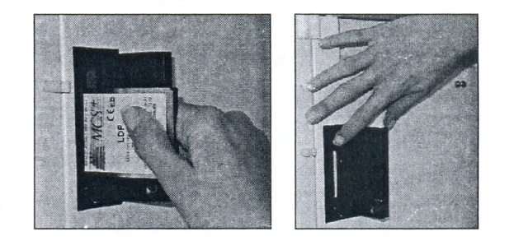
MCS+ protocol insertion and removal

- Immediately after the power on a series of internal self diagnostic test will be conducted prior to each collection procedure.
Once the self diagnostic test completed the bar graph screen message will indicate 100 %, to confirm that tested system are functioning properly.
- The MCS + device screen will display please lock, unlock and relock the centrifuge lid.

- Selecting protocol Option
When device has performed self diagnostic test the operator will proceed to select certain protocol option. Chose the TPE option (with substitution).

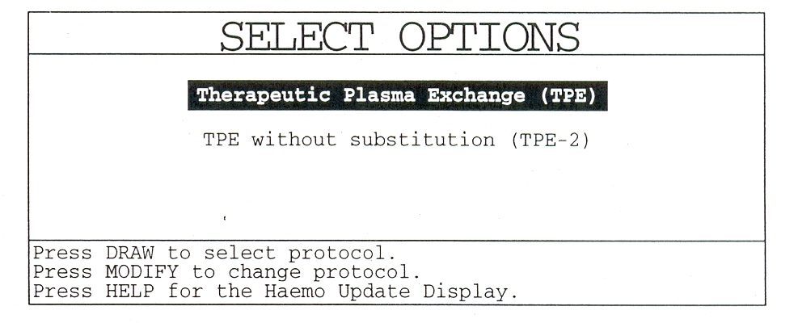

E. DISPOSABLE INSTALLATION
a. The MCS + is now ready for disposable installation. Two versions of the TPE disposable are available. The List No 980E has a 225 ml Latham bowl, and the List No 981 E has a 125 ml small volume Latham bowl. The MCS + automatically detects which disposable has been installed upon installation of the white pump cartridge.
- Extend the weigher arm at 90⁰
- The operator should inspect the disposable material prior to, as well as during installation on the MCS + device using the following guidelines.
- Verify that the disposable set correspond with the selected protocol and options.
- Verify that that neither the packaging kit nor cover has been damaged.
- Inspect all tubing section during installation and insure that no occlusions are present.
- Disposable set installed according to the information display on screen

The following will be displayed on the screen:

TPE Install
Please Install the Disposable:
Load the Bowl
Close the Centrifuge Cover
Snap the Pump Cartridge in Place
Install the Tubing in the Line Sensor
Install the System Pressure Monitor (SPM)
Install the Donor Pressure Monitor (DPM)
Press HELP for More Information

Note: Do not load the disposable until the above message is displayed.
Note: Before opening the protective packaging, either wash your hands or apply clean gloves to eliminate the chance of powders or other deposits collecting
on either the machine or disposable component surfaces. This helps ensure that
the performance of the optics sensors is not adversely affected.
Note: After each item has been installed, a beep is heard and the item disappears from the screen. A help message is available with each item that tells the operator how to proceed.
- Extend both arms of the IV poles fully.
- Open the Centrifuge Cover.
- Remove the spike connector with integrated drip chamber from the tub and temporarily hang over the lower arm of the right hand IV pole. This is the substitution fluid line.
- Remove the Latham bowl and the white pump cartridge from the disposable tub. Place the bowl into the Centrifuge Well. Ensure that the centrifuge chuck holds the bowl securely in place. A beep sounds and the text "Load the Bowl" disappears from the screen.
- Close the Centrifuge Cover and tighten the Centrifuge Cover Switch. A beep sounds and the text "Close the Centrifuge Cover" disappears from the screen. Ensure that the effluent port of the bowl (lower port) is facing to the right of the MCS + . Make sure that the tubing is not under the Centrifuge cover.
- Loop the tubing on the white pump cartridge around the Blood and Transfer
Pumps. Snap the pump cartridge in place, ensuring that it locks in place. The
text "Snap the Pump Cartridge in Place" disappears from the screen.
The MCS + automatically loads the tubing into the pumps at a later stage.
- Remove the 500 ml air bag from the disposable tub and hang it on the top
front pins with the port down.
- Floss the clear line sensor tubing through the Line Sensor. Make sure that the
connector of the effluent tubing is placed in front of the Line Sensor. The
text "Install the Tubing in the Line Sensor" disappears.
If the line sensor tubing, insertion was not detected during setup, the following
screen will be displayed. Press YES to continue if the tubing was loaded in the sensor or, load the line in the sensor.
TPE Install
Please Install the Disposable:
Install the Tubing in the Line Sensor
Is the Line Sensor Tubing Loaded?
Press HELP for More Information
Press YES to continue

- Install the yellow-striped effluent tubing into the Yellow Valve by flossing the tubing into the valve channel.
- Install the green-striped effluent tubing into the Green Valve by flossing the tubing into the valve channel.
- Connect the System Pressure Monitor (SPM) Luer to the SPM port. Push the
filter inward against the port until it goes no further and twist the filter about
a quarter turn. The text "Install the System Pressure Monitor (SPM)" disappears from the screen.
- Remove the five litre waste bag and hang it on the three bag pins located on
the right side panel of the MCS + .
- Using aseptic technique, remove the caps from the Luer connectors on the
green-striped tubing and the waste bag. Connect the green-striped effluent
tubing to the five litre waste bag.
The effluent side of the harness is now loaded. Next, install the fluid substitution
section of the harness.
- Remove the one litre temporary substitution fluid bag from the tub.
- Hang the temporary substitution fluid bag with ports down on the weigher arm. Ensure that the bag hangs freely.
- Install the clear substitution fluid line from the temporary substitution bag
into the Clear Valve (Top Deck) by flossing the tubing into the valve channel.
Note: Do not spike the substitution fluid lines yet. You will be prompted to do this as part of the prime procedure.
- Install the blue-striped tubing, located between the white pump cartridge and
the substitution fluid bag, into the Blue Valve by flossing the tubing into the
valve channel.
The fluid substitution section of the disposable is now loaded. Next, load the inlet side of the harness.
- Remove the blood filter from the disposable tub and place it in the filter housing located on the front panel of the MCS +.
- Follow the red-striped tubing from the white pump cartridge. Install the red
striped tubing into the Blood Line Air Detector (BLAD), by flossing the tubing
into the air detector channel.
- Install the red-striped tubing, located between the BLAD and blood filter, into
the Red Valve by flossing the tubing into the valve channel.
- Connect the Donor Pressure Monitor (DPM) filter on the DPM. Push the filter
firmly onto the port until it goes no further and twist the filter about a quarter
turn. The text "Install the Donor Pressure Monitor (DPM)" disappears from
the screen.
Warning! Always be sure to push and twist the DPM filter onto the
DPM port. Failure to do so may result in blood contacting the filter.
Once the DPM filter membrane has been wetted with donor blood, the
MCS + wi 11 no longer be able to properly monitor venous pressure.
- Follow the clear tubing from the bottom of the blood filter chamber to the left. Install the clear tubing into the Donor Line Air Detectors (DLAD 1 and DLAD 2) and into the tubing guide located to the left of the DPM.
- Remove the red-striped twin tubing from the tub. Temporarily hang the tubing over the left hand IV pole.
- Remove the anticoagulant (AC) line and blue AC pump cartridge from the tub.
- Loop the tubing on the blue cartridge around the AC Pump. Snap the pump cartridge into place to ensure that it is fully seated.
- Thread the clear AC tubing through the Anticoagulant Air Detector (ACAD), by flossing the tubing into the air detector channel.
Note: Do not spike the anticoagulant bag yet. You will be prompted to do this after the pumps have been loaded.
Note: Do not load the drip chamber yet. The drip monitor chamber is loaded
after the AC bag has been spiked
- Close the white ratchet clamp on the "pig tail" line near the blue needle connector. Ensure that the white Luer cap on the needle connector is securely
locked.
- Remove the empty disposable tub from the lid and recycle or discard it.

The disposable installation is now been complete. Before autoloading the pumps,
check that the disposable has been installed correctly. The following screen is dis-
played at this time:
TPE Install
Please Confirm that:
The Valves are Loaded
The Pump Tubing is Looped
The Temporary bag is on the Weigher
The Waste Bag is connected
Press DRAW to load the pumps.

- Check that all valves have been loaded correctly. The following valves
should be loaded: Red, Blue, Yellow, Green and Clear.
Note: The Orange, Purple and White Valves are not used in the Plasma Exchange protocol.
- Confirm that the tubing is looped on the Blood Pump, Transfer Pump and AC Pump.
- Confirm that the substitution bag is on the weigher with ports down.
- Confirm that the waste bag is a~ached to the green-striped effluent line and hangs on the right side panel of the MCS +.
- Confirm that the "pigtail" line is clamped and Luer lock is closed.
- Check that all components of the disposable are properly installed.
Once you have ensured that the disposable has been installed properly, continue with Autoloading the Pumps. Press the DRAW key.

F. Autoloading Pumps
The autoloading pump heads turn several times and load the tubing into the pump heads.

TPE | Install
AUTOLOADING PUMPS
Press STOP to stop the pumps.

G. Priming the disposable

Once the pumps have been loaded the MCS+ displays the following screen.

TPE |  |  |  | Install
 | Please Confirm that:
 | The |  | Sample Pouch Line is Clamped
 | The |  | Needle Line | is Clamped
 | The |  | Anticoagulant | is spiked
 | The Drip Monitor |  |  | is Loaded
 | (The Substitution Bag is |  |  |  | Spiked | (only TPE)
Preps | PRIME | to | prime the disposable.

To prime the disposable, proceed as follows:
- Ensure that the draw line is clamped.
- Using aseptic technique, spike the AC bag with the anticoagulant spike.
- Squeeze the drip chamber to draw approximately 3 mm of AC into the AC
drip chamber.
- Hang the AC bag on the lower arm of the left IV pole.
- Install the drip chamber into the drip monitor housing so that it is seated
against the bottom surface of the housing.
- Using aseptic technique, spike the substitution fluid with the spike connectors on tubing installed through the Clear (Top Deck) Valve.
- Hang the substitution fluid on the fully extended upper arm of the right IV
pole.
Note: Provided that proper asepti technique is used, additional bags and/or bottles of substitution fluid may be added throughout the procedure.
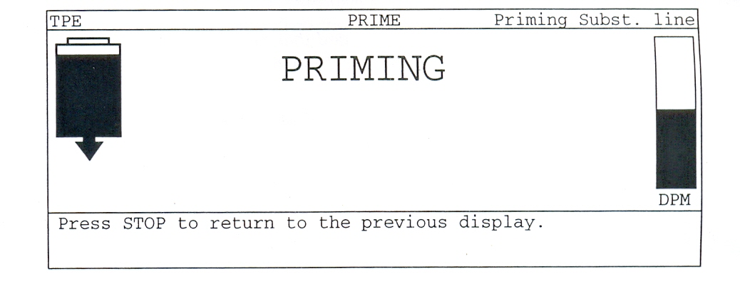

If TPE is selected, the substitution line is automatically primed through gravity
flow. Before the AC line is primed, all pumps stop and the Clear valve opens. The
substitution fluid flows from the substitution bag on the right IV pole into the Temporary substitution bag on the weigher with ports down. The priming sequence ends when the weigher detects 15 ml of substitution in the temporary bag. If the weight does not change within 20 seconds after priming started, the error screen below is displayed.

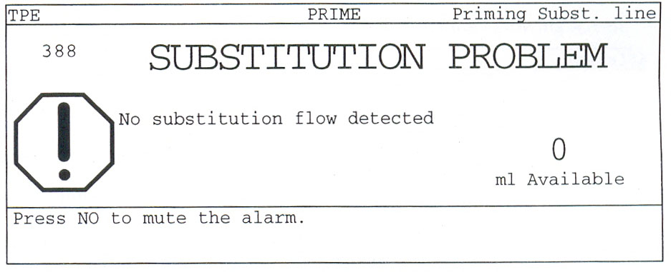

When 'the weigher detects 5 ml of substitution solution, the previous screen returns until the substitution priming sequence is completed.
Then the Clear valve is closed and the AC line is primed.

The Prime Mode automatically primes the disposable with anticoagulant. The AC
and Blood Pumps turn simultaneously to prime the AC line and donor line.
Throughout the priming, the anticoagulant flow is monitored by the drip monitor. The anticoagulant priming sequence stops when DLAD 1 and DLAD 2 detect fluid.
Note: You should be able to see the drops of anticoagulant as the AC Pump turns. If the drip chamber is overfilled, remove the AC bag from the IV pole, invert the bag and squeeze the drip chamber. This forces some of the AC back into the AC bag.
Note: Once the disposable set has been primed it is recommended that it be
used within four (4) hours.

H. ENTERING DONOR STATISTICS AND PROCEDURAL INFORMATION
The MCS + is now ready to be programmed for the Therapeutic Plasma Exchange. The Haemo Calculator screen is displayed. The preset parameters may be modified using the Yes (+) and No (-) keys. The Modify key is used to scroll through the listed parameters.

Haemo Calculator

The Haemo Calculator may be accessed at any time during the collection procedure by pressing the Help Haemo Calculator key twice. The Haemo Calculator screen contains patient information in the left-hand column and procedural information in the right-hand column. The top section of the screen contains a running update of procedure statistics.
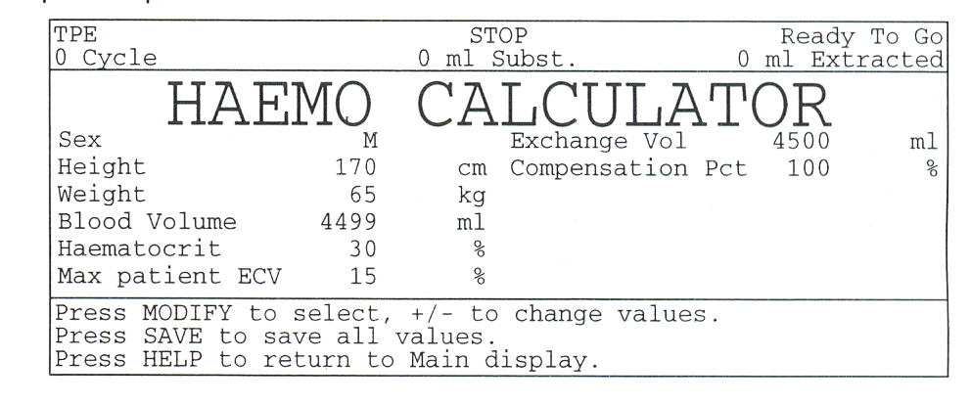

The Haemo Calculator is used to adapt the programming of the MCS + to the patient and treatment.

Patient Information parameters
The patient parameters entered are Sex, Height, Weight and Haematocrit. These parameters are used to estimate total blood volume and plasma volume. Blood volume and plasma volume are used to customize the procedure to the patient.
1. Sex Enter the patient's sex, female or male.
- Height Enter the patient's height in centimeters.
- Weight Enter the patient's weight in Kilograms.
- Blood Volume Based on the sex, height and weight of the patient, the MCS + calculates an estimate of the total blood volume of the patient. The patient blood volume is used to estimate the patient's plasma volume and set Extra Corporeal Volume (ECV) warning limits based on 15% ECV (see the section on ECV Management for more information on this subject).
Note: The blood volume estimation calculations used by the MCS + are for adults. When performing pediatric procedures, use local procedures for estimating the total blood volume.
- Haematocrit Enter the Haematocrit as a percentage. The patient Haematocrit must be set accurately to estimate the total volume of plasma that may be collected per collection cycle.
- Max Patient ECV ECV at wh ich the MCS + shall warn the operator. The
MCS + calculates the overall patient ECV throughout the procedure.

I. Product Parameters
- Exchange Volume This is the total volume of plasma to be collected during
the procedure. The volume of plasma to collect may either include or ex-
clude the anticoagulant (AC) in the plasma. Including or excluding AC from
volume accounting can be selected by the parameter "Volume Accounting" in the Modify Parameters Screen.
- Compensation Pct. The "% Plasma Replaced" determines how much substitution fluid is returned to the patient. Typically, this parameter is set to 1 00% (i.e. the volume of fluid returned will be equal to the amount of plasma re- moved - isovolaemic). When more fluid is to be returned than removed, the "% Replaced" is higher than 100 % (hypervolaemic). When less fluid is to be returned than removed, the "% Replaced" is to be programmed at less than 100% (hypovolaemic).

  - HaemoUpdate
The Haemo Update screen contains a full detailed running update of all proce-
dure statistics. Press the HELP key once to access the Haemo Update screen. The
left hand column of the Haemo Update screen gives an update of the procedure
information; the right hand column gives detailed exchange volume statistics.
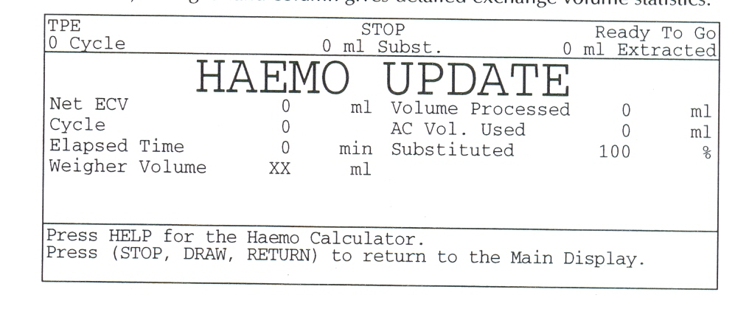

Procedure Update Information
- Net ECV is the difference between fluid volumes drawn and returned through the needle. This volume includes the total volume of whole blood drawn from the Patient and the total volume of red cells and substitution fluid returned by the MCS + during the procedure.
A negative net ECV indicates that the patient has received more fluid than the total volume withdrawn. When the net ECV is positive, more fluid has been removed than reinfused.
Note: The displayed value does not depend on the Volume Accounting parameter chosen.
- Cycle is the current cycle number.
- Elapsed time is the number of minutes since the procedure was started by
pressing the DRAW key.
- Weigher volume is the actual volume in the temporary substitution bag on
the weigher.
5. Volume Processed is the total volume processed so far. The displayed value depends on the Volume Accounting parameter chosen and whether this has been selected to include or exclude anticoagulant volume.
- AC Volume Used This is the total volume of anticoagulant used in ml.

K. Plasma Exchange Information
The Modify Parameters screen can be accessed from the Main Screen at any time by pressing the MODIFY key. The top section of the screen contains a running up- date of the most vital procedure statistics.
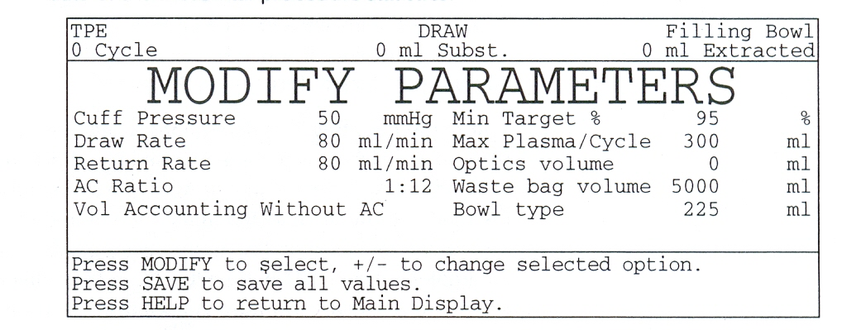

- Draw Speed This is the pump rate that the MCS + aims to maintain during the Draw Mode of the procedure. Depending on the venous access, the
MCS + may adjust the actual draw speed to a lower rate.
- Return Speed This is the pump rate that the MCS + aims to maintain during the Return Mode of the procedure. Depending on the venous access, the MCS + may adjust the actual return speed to a lower rate.
- AC Ratio This is the ratio of anticoagulant which is necessary to anticoagulate whole blood. The "AC Ratio" depends on the type of anticoagulant used.
- Volume Accounting This determines whether or not the volume of anticoagulant in the plasma is to be accounted for as plasma. If this parameter is set to "Without AC", the volume of AC in the collected plasma is subtracted fromthe total volume of collected fluid. The volume of substitution fluid to be returned will be based on the plasma without AC. If the "Volume Accounting "Parameter is set to with, then the AC in the collected plasma is regarded asplasma and substitution fluid is administered based on the total volume of plasma including AC volume.
- Min Target Pct. This determines the minimum percentage of the target plasma exchange volume that must be reached before the procedure can end.
- Max Plasma/Cycle This determines the maximum volume of plasma that can be collected during each cycle.
- Optics Volume This determines the volume of anticoagulated whole blood
that is pumped after the bowl optics detects the buffy coat. This is particularly useful to maximize the amount of plasma that can be collected each cycle, typically with high haematocrit patients.
- Waste Bag Vol. this is the size of the waste bag used with the disposable.
The MCS + will warn the operator when the waste bag needs to be replaced.
- Bowl Size This is the type of bowl in the disposable. The default is set automatically according to the list number of the disposable installed. If a bowl of different size is exchanged during the procedure, the new bowl type must be programmed using MODIFY.

L. HANDLING SUBSTITUTION FLUID
The MCS + Plasma Exchange Protocol manages the substitution fluid, when the
TPE protocol is selected. The substitution fluid hangs on the upper arm of the right hand IV pole. During the Draw Mode, the MCS + automatically delivers the correct volume of substitution fluid into the temporary substitution bag on the weigher. The volume of substitution fluid depends on the expected substitution fluid requirements. Whilst transfering and adequate volume of substitution fluid into the temporary substitution fluid bag, the MCS + displays the message "FILLING Temp. Subst. BAG" on the screen.
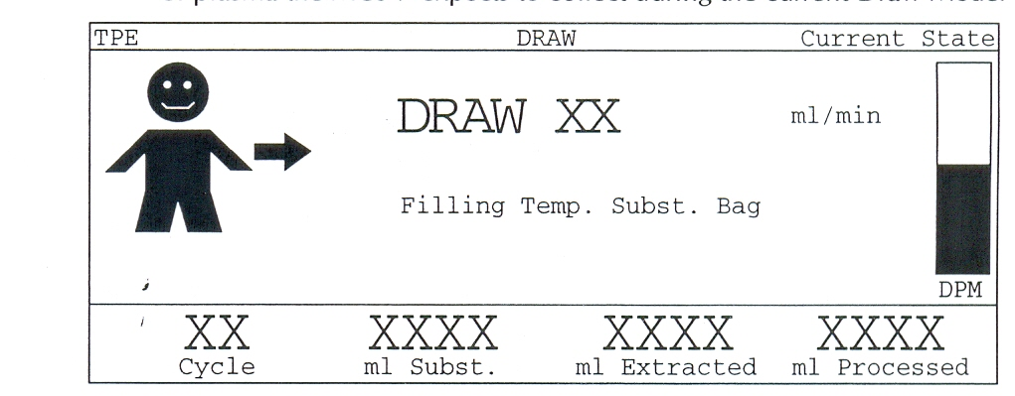

The Return Mode, the substitution fluid in the temporary substitution fluid bag
on the weigher is mixed by the transfer pump with the contents being returned
from the bowl. This allows a continuous and rapid return of cells and fluid.

EXTRACORPOREAL VOLUME MANAGEMENT
The MCS + Therapeutic Plasma Exchange Protocol continuously monitors Extracorporeal Volume (ECV). The MCS+ TPE protocol gives a warning once ECV reaches 15% of the total estimated patient blood volume (the parameter "ECV Warning" is set in Haemo Calculator). The ECV is defined as the difference between fluid volumes drawn and returned through the needle, regardless of the volume accounting method chosen (Modify). Once the limit is reached, the pumps stop. The message "ECV Limit reached (15%)" is displayed with an audible alarm sound. Note that the centrifuge keeps spinning. At that point the operator is given the option to either continue the Draw Mode by pressing the DRAW key, or to enter into the Return Mode by pressing the RETURN key.

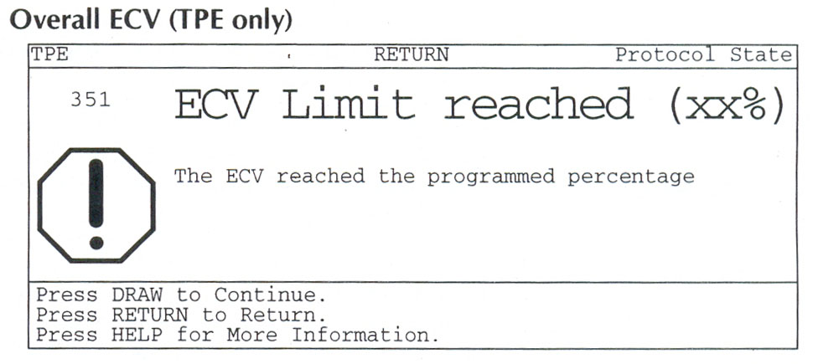

M. PREPARATION FOR THE COLLECTION PROCEDURE
After the MCS+ disposable is installed and primed, the MCS+ is ready to start a procedure. The first step in performing a TPE procedure is programming the MCS + by entering the patient information into the left column of the Haemo Calculator. The procedure targets are programmed in the right column of the Haemo Calculator and in the Modify Parameters screen.
Warning! Haemonetics recommends handling all biologically contaminated materials pursuant to the policies and procedures dictated by local medical facility's Infection Control Plan.

- Place a haemostat on the red-striped double lumen (patient/AC) tubing approximately 6 to 9 inches from the needle connector.
Warning!: There must always be a haemostat on the double lumen tubing prior to connecting the catheter to the disposable. Do not remove the haemostat until the MCS + is in the Draw Mode and the operator has verified that the blood pump is turning clockwise.
- Remove the heparinized saline present in the central catheter according to local standard operating procedures.
- Remove the Luer Cap from the needle connector on the disposable.
- Connect the catheter to the disposable, using aseptic technique.
Note: A blood sample may be obtained through the sample port after connecting the catheter to the disposable.

N. Draw Mode
- The MCS + fills the disposable centrifuge bowl with anticoagulated whole blood. Sterile air is displaced from the bowl into the air bag at the front of the MCS+. Whilst the MCS+ is filling the bowl, substitution fluid flows into the substitution fluid bag on the Weigher. The volume of substitution fluid transferred depends on the programmed parameters and the volume of plasma the MCS+ expects to collect during the current Draw Mode.

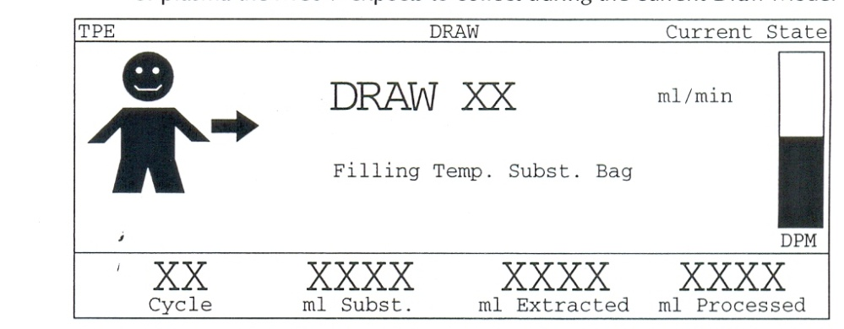
- When the air/plasma interface is detected by the Bowl Optics, the message Air/Plasma Interface appears in the top right corner. At this point the MCS + takes the reference for air at the Line Sensor and starts counting the "WATERTEST" Volume (ml of anticoagulated whole blood pumped by the MCS + after bowl optics detection and until the Line Sensor identifies that fluid has existed the bowl).
- Plasma begins to overflow from the bowl into the waste bag once all sterile air has been displaced from the bowl. As plasma is collected, the MCS+ may add additional substitution fluid into the substitution fluid bag.
- When the buffy coat is detected by the bowl optics, the MCS + enters the end of collection algorithm. Draw Mode ends when one of the condition below is met:
1. The "Optics Volume" after the optic detection is reached, or
- the line sensor detects the buffy coat emerging from the bowl, or
- the “Maximum Plasma/Cycle" is reached, or
- the MCS + maximum ECV Limit is reached.
- Once the MCS + has completed the Draw Mode, the pumps stop and centrifuge break.
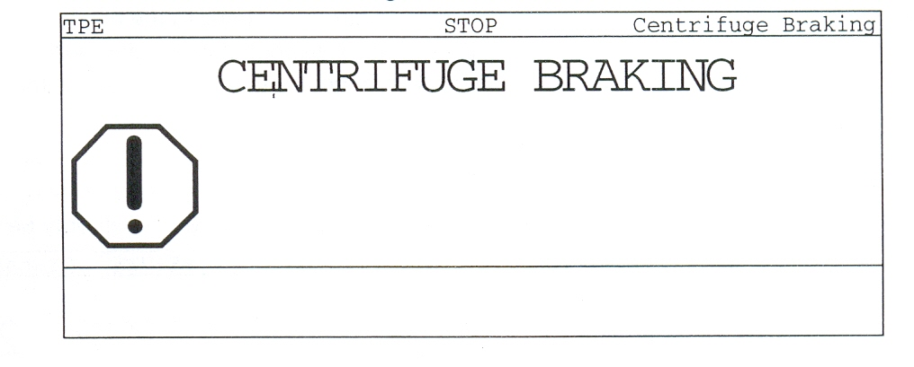

O. Return Mode
During the Return Mode, packed cells from the bowl and fluid from the temporary substitution fluid bag are mixed and returned to the patient (if substitution is enabled). This allows a rapid Return Mode with a constant Return Pump rate and constant low Haematocrit for reinfusion. The Return Mode consists of three phases:
- Returning bowl contents and most of the substitution fluid simultaneously,
The Blood Pump starts turning counter clockwise returning the contents of the bowl, and the Transfer Pump mixes substitution fluid with it. The "ml Substituted" on the display increases, reflecting the volume of substitution fluid pumped by the Transfer Pump. Air is displaced from the air bag into the bowl as it is being emptied.
- Transfering the remaining substitution fluid into the spinning bowl.
- Ending the return phase.
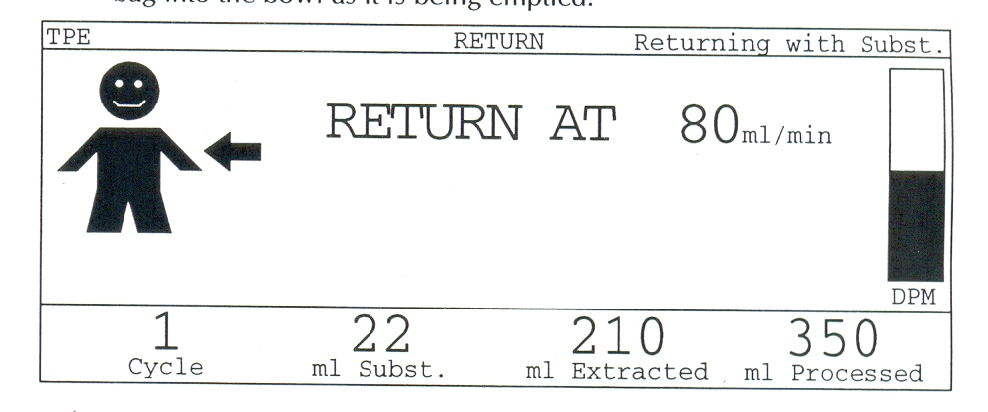

- Once the volume remaining in the bowl is below 60 ml, the Blood Pump stops and the Transfer Pump transfers substitution fluid into the spinning bowl, thus lowering the Haematocrit of the remaining contents of the bowl.
At the beginning of each return cycle, the MCS + calculates the amount of substitution fluid to return during the current cycle. If the operator changes the compensation percentage during Return Mode, it will only be used for the next cycles.
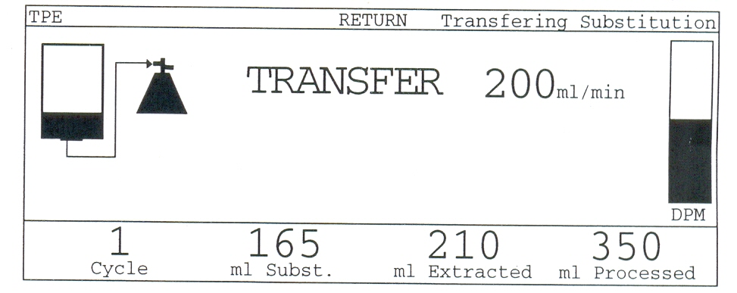
- After the brief substitution fluid transfer, the Centrifuge stops and the, Blood Pump resumes the Return Mode. Shortly after this, the bowl will be empty and the BLAD will detect air. At that time, the Blood Pump slows to 40 ml/min and returns a fixed amount of blood to empty the filter chamber.
These collection cycles are repeated until the programmed volume of plasma has been collected.
Full procedure statistics are available at any time during the procedure by pressing the HELP key once to enter the Haemo Update screen.

P. Procedure Complete
Once the plasma exchange procedure has been completed, the MCS + beeps and displays the "Procedure Complete" screen. At this time, you may perform an optional post-procedure blood sample. Then, disconnect the patient and discard the disposable. After disconnecting the line, heparinised the central venous catheter for the next cycle.
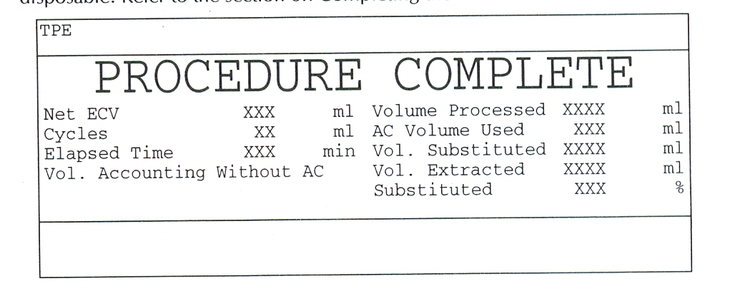
- DOCUMENTATION:
During the procedure and after completing the procedure, document in the format and entered in the register.

- REFERENCES:
- Haemonetics MCS + manual + LN 9000 – 220 E plasma protocols PPP and FFP.
- User manual Haemonetics MCS +.

- END OF DOCUMENT.

