Model SOP

Standard Operating Procedure

Name of the facility / activity : Apheresis for Single Donor Plasma (Plasmapheresis)

SOP no. | Effective Date | Pages | Prepared by | Authorised by
7.2 | 27-11-2000 | 13
Version | Review Period | Date of Review | Reviewed by | Number of copies
VI | 2 years | 01-01-2015 |  | 10
LOCATION : Apheresis Unit
SUBJECT : Single Donor Plasma (Plasmapheresis)
FUNCTION : Selective removal of plasma by cell separator machine (Haemonetics MCS +)
DISTRIBUTION: Medical officer
Master File

- SCOPE & APPLICATION:
The selective separation and removal of plasma from withdrawn blood and the remainder of the blood then being retransfused into the donor through cell separator is called plasmapheresis. This standard operating procedure applies to apheresis procedure using the haemonetics cell separator MCS Plus machine for single donor plasma collection. Single donor plasma is useful component in bleeding patients, liver failure, DIC and therapeutic plasma exchange procedures.

- RESPONSIBILITY:
It is the responsibility of the trained Staff Nurse and Technicians to perform the procedure under the supervision of Medical officer.

- MATERIAL REQUIRED
- Equipment
- Haemonetics Cell Separator Machine
- Platelet Apheresis Kit (Haemonetics)
- BP instrument
- Stethoscope
- Tube Sealer
- Emesis Pan
- Urinal
- Tornique
- Reagents and solutions
- An adequate quantity of Anti coagulant solution
- Spirit
- Cotton swab
- Band Aid
- Emergency injection and drugs

- PROCEDURE:
The operator’s manual for the haemonetics cell separator and the direction for use with the apheresis kit should be followed at all times.
Terminology: Apheresis is a Greek word meaning “to take away” involve the selective removal of blood components from blood donors / patients. Automated blood processing devices are used for both component preparation and therapeutic application of apheresis. In apheresis instrument centrifugal forces separate blood into component on the basis of difference in density. A measured amount of anti coagulant is added to the whole blood during drawing blood from the donors / patients.
This term can be sub divided into three categories
          - Cytaphresis: Selective removal of cellular component from whole blood. These include Erythrocytes, Thrombocytes, Leucocytes and stem cells.
          - Plasma Apheresis: Selective removal of plasma containing elements refer to as fractional components, such as clotting proteins and immunoglobulins.
          - Platelet Apheresis: Selective removal of platelets from whole blood.

Plasmapheresis:
The blood is pumped into the rotating bowl in which layering of component occurs on the basis of the density. The desired fraction is collected in a separated bag and remaining elements are returned to the donor by intermittent flow.

- Criteria for donor selection for plasmapheresis is same as for normal blood donation
- Written consent on donor card before procedure is commenced and the procedure should be explained to the donor with its benefits and risk.
- The medical officer shall certify that donor is fit for apheresis through donor selection.
- The procedure shall be carried out by a trained person under supervision of a medical officer.
- If during the procedure RBCs can not be retransfused than at least 12 week shall elapsed before a second procedure is conducted.
- The quantity of plasma separated from the blood of a donor shall not exceed 500 ml per sitting and once in a fortnight or shall not exceed 1000 ml per month.
- Good venous access for successful phlebotomy as well as return of remaining component of blood to the donor.
- Minimum height and weight for the blood volume of 4 litres.
- CBC performed prior to plasma apheresis.
- TTI test performed prior to plasma apheresis.
- Total blood process shall not be more than total blood volume (ECV should not exceed more than 15%).
- The worksheet for the procedure be kept ready to be filled during each cycle.

- Overview:
The smartcard permit to protocols PPP and FFP to collect a pre set volume of plasma from a healthy donor.

- Preparing the MCS+ device
- Insert the PPP / FFP protocol card into the open card port (right side panel) until the release tab pops out when the MCS + device is powered off.
- Close the card port door securely.

Power on the MCS+ device.
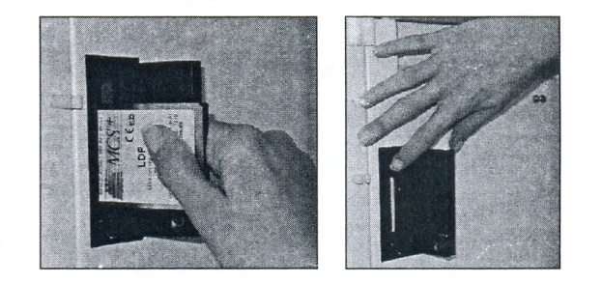
MCS+ protocol insertion and removal

- Immediately after the power on a series of internal self diagnostic test will be conducted prior to each collection procedure.
Figure page 3

Once the self diagnostic test completed the bar graph screen message will indicate 100 %, to confirm that tested system are functioning properly.
- The MCS + device screen will display please lock, unlock and relock the centrifuge lid.

- Selecting protocol Option
When device has performed self diagnostic test the operator will proceed to select certain protocol option. Chose the platelet poor plasma (PPP option)
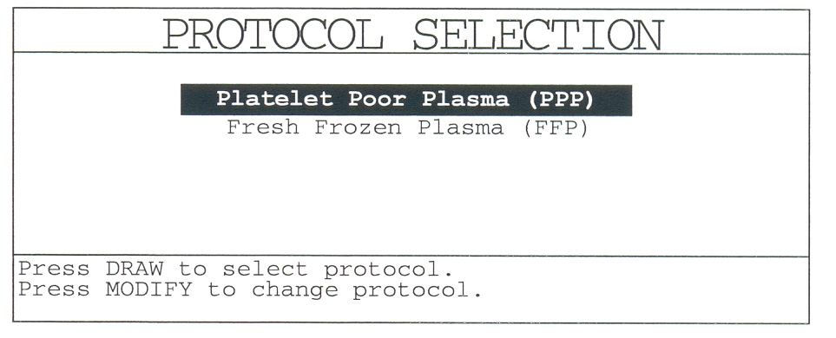
Number of bags 1 and saline compensation No is selected.

- Disposable set installation
MCS + displays the following screen
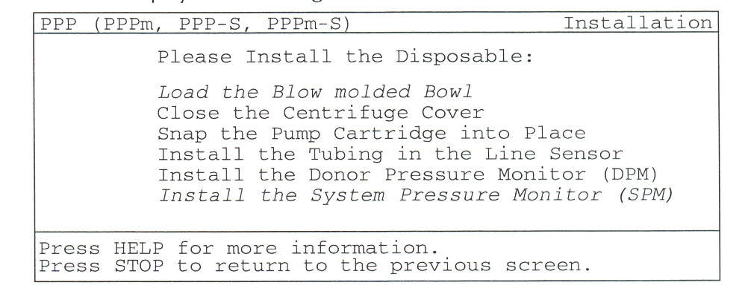
- Extend the weigher arm at 90⁰
- The operator should inspect the disposable material prior to, as well as during installation on the MCS + device using the following guidelines.
- Verify that the disposable set correspond with the selected protocol and options.
- Verify that that neither the packaging kit nor cover has been damaged.
- Inspect all tubing section during installation and insure that no occlusions are present.
- Disposable set installed according to the information display on screen
- Plasmapheresis sets do not include pump stop adampters, therefore a spare adapter must be snapped on the AC pump and another on the transfer Blood pump
Step 1 to 3 for BMB bowl installation
- Open the centrifuge cover and make sure the Bowl adapter is properly installed.
- Open the bowl package. Be careful not to disturb the caps on the bowl inlet and outlet ports.
- Insert the bowl into the adaptor (see MCS + General Operator’s Manual for drawing) by pressing on the top of the bowl body. Avoid touching the head of the bowl.
Make sure the bowl is inserted all the way down.
Continue installation at step 6
Step 4 to 6 for Latham bowl installation
- Open the bowl package. Be careful not to disturb the caps on the bowl inlet and outlet ports.
- Remove the Latham Bowl from the disposable tub and place it into the centrifuge well.
The chuck will hold the bowl in place.
The text for loading the Bowl disappears for the screen.
- Position the bowl so that the feed tube (the higher port) faces to the left of the machine and the effluent port faces to the right of the machine.
- Close the Centrifuge Cover, ensuring that the effluent tubing is facing to the
right of the MCS + (clear tubing/Iow port). Lock the centrifuge Cover. Check
that a gap can be seen between the silver metal ring and the header of the
bowl. The text for closing the Centrifuge Cover disappears from the screen
- Make sure the two pump stop adapter bars are properly installed in front of
the blood pump and AC pump (see general MCS + operator's manual for drawing).
- Remove the plasma bag(s) from the bag(s) storage area and hang the plasma bag(s) on the weigher arms with the ports up.
- Insert the outlet tube in the line sensor.
- Effluent Line Installation:
Option 1 bag: Place the effluent line in the yellow valve.
12. System Pressure Monitor (SPM) luer, should be connected to the system pressure monitor port. The text for installing the SPM disappears. Ensure that the tubing is not clamped. The effluent side of the harness, from the bowl to the collection bags, is now loaded. Now, load the inlet side of the harness.
13. Install the Donor Line filter chamber in the holder located on the left hand
side of the front panel.
- Direct the tubing from the bottom of the filter chamber to the left and install
the tubing up into the two Donor Line Air Detectors and into the tube guide
located to the left of the Donor Pressure Monitor (DPM).
- Match the tubing from above the filter chamber to the blood pump (red on
some disposable sets) with the red ring indicating the donor valve. Thread the
tubing through the donor valve.
- Direct the tubing from the red valve to the top of the MCS + and load the
Blood Line Air Detector (BLAD). Ensure there are no kinks.
- Load the blood pump from front to back with the segment of tubi ng between
the two blue pump stop collars.
- Place the pump stop collar closest to the filter in the front groove of the
blood pump converter.
- Install the tubing in the autoload guide on top of the pump.
- Place the other pump stop collar in the back groove of the blood pump
converter.
- Remove the anticoagulant line tubing from the tubing storage area of the dis-
posable tub and remove the paper tab.
- Load the tubing into the AC pump from back to front.
- Place the tubing through the rear tubing guide using the AC spike and
silk- screened icons to assist with installation.
- Install the tubing in the autoload guide on top of the pump.
- Place the pump stop collar in the front groove of the AC pump converter.
- Thread the AC tubing through the anticoagulant air detector.
- Connect the DPM luer at the top of the filter chamber, to the monitor port on the left side of the MCS+. Remove the protective cover from the luer. Ensure that the tubing is not clamped. Push the filter inward against the port until it goes no further, and turn slightly to the right. A beep sounds and the text for installing the DPM disappears from the screen.

- Autoload the Pumps

The following display appears. Check that the remaining components of the disposable are loaded.
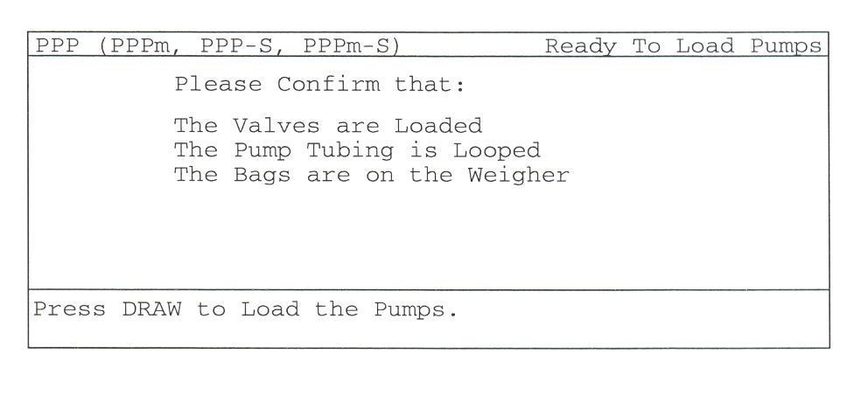
The MCS+ is equipped with an automatic pump loading feature. To autoload the
pumps, proceed as follows.
- Check that the pump tubing is properly looped around the autoload guides
(Anticoagulant and Blood Pumps).

- Press DRAW to load the pumps. The pump heads revolve several times and
guide the tubing into the roller heads.

- Prime the Disposable
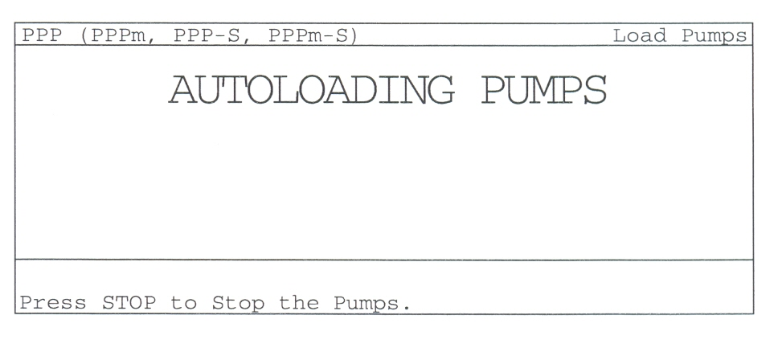
After autoloading the pumps, the following screen is shown.
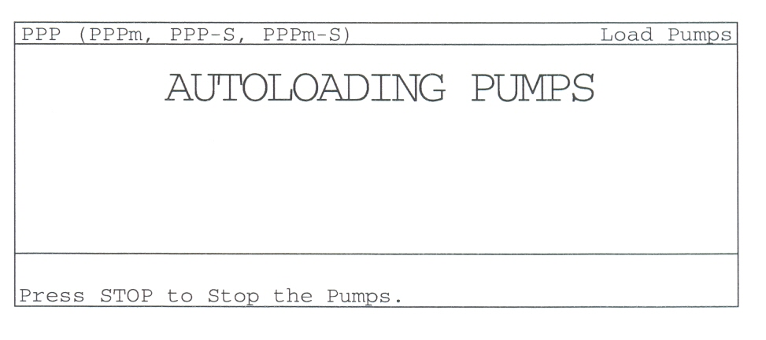

The MCS+ is equipped with an automated priming feature. To prime the system,
proceed as follows.
- Using aseptic technique, spike the AC bag with the anticoagulant spike.
Hang the AC bag on the lower arm of the IV pole.
Warning! To ensure that the AC line is spiked onto the AC bag, follow the line visually to the Anticoagulant Pump. If AC line has not drip chamber skip steps 2 and 3.
- Squeeze the drip chamber to fill about 1/8" of AC in the drip chamber.
- Install the drip chamber into the drip monitor housing so that it is seated
against the bottom surface of the housing.
- Close the clamp on the needle line.
- Close the clamp at the sample pouch (if any).
- Press PRIME.
The following screen, indicating the current mode of operation, is shown once
the PRIME key has been pressed.
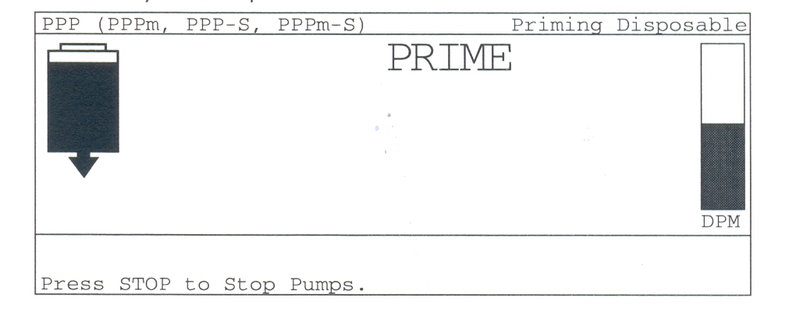

Note: See the drops of anticoagulant in the drip chamber as the AC Pump turns. If the drip chamber is overfilled, remove the AC bag from the IV Pole, invert the bag, and squeeze release the drip chamber. This will bring some air back from the bag to the chamber.
The Prime mode automatically primes the disposable with anticoagulant. The Anticoagulant and Blood Pumps turn simultaneously to prime the anticoagulant
line, and then the donor line, until the anticoagulant reaches the DLAD 1.
Note: Once the disposable set has been primed, it should be used within four (4) hours.

- PREPARE THE MCS +

Upon completion of priming, the MCS + advances to a ready mode. In this state, the operator can modify any protocol parameters or begin the procedure. The display panel will show the following:
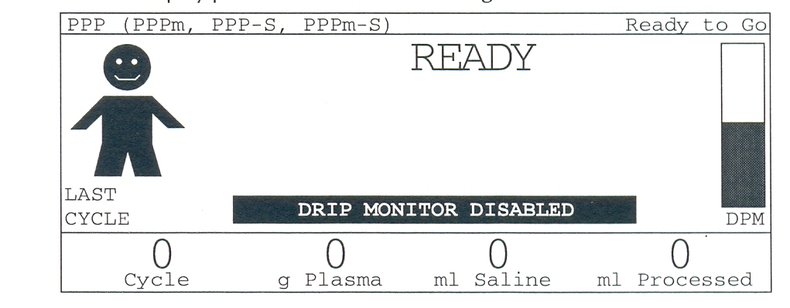

Modifiable Parameters

- Cuff Pressure The default is 50 mmHg, with a range of 0 mmHg to 100 mm-
Hg. the Pressure Cuff may be adjusted in increments of 5 mmHg by using the
"+ " and "-" keys.
- Draw Speed This controls the target Blood Pump speed during Draw. The ac-
tual speed may be lower because of poor flow conditions. The default is 60
ml/min., with a range of 20 ml/min. to 100 ml/min.
- Return Speed This parameter controls the target Blood Pump speed during
Return. The actual pump speed may be lower because of poor flow condi-
tions. The default is 90 ml/min., with a range of 20 ml/min. to 150 mllmin.
- Target Plasma This default setting determines the total plasma to be collected
during the Platelet Poor Plasma procedure. This parameter ensures that only
the desired volume of plasma is collected from the donor.
- AC/Blood Ratio This parameter controls the Anticoagulant Pump to Blood
Pump ratio during Draw. The range is 1:8 to 1 :16, with a default of 1 :16.
A ratio 1:X means that 1 volume of AC is mixed with X-1 volumes of whole
blood. The recommended ratios for ACD is 1:12.

Max Plasma/Cycle The default setting determines the plasma volume to be
collected during each cycle. The default for this value is 300 ml. If a different
value is desired, it can be selected by using the UP & DOWN ARROWS re-
ferred to within the MODIFY PROGRAM key grouping. This parameter en-
sures that only a set amount of plasma is collected each cycle. This prevents,
for low Ht donors, the possibility of collecting all available plasma in the first
cycles which could potentially cause donor discomfort (a smaller volume per
cycle allows the body to physiologically adjust to volume shifts).

- Haemocalculator Menu
After priming the disposable kit the Haemocalculator parameter will appear on screen. The individual donor parameter are entered according to certain collection target like platelet yield, volume processed & number of cycle & procedure duration:
- Sex is the gender of the donor expressed as Female (F) or Male (M)
- Height is the height of the donor expressed in centimetres.
- Weight expressed in kilogram.
- Blood volume is the estimated total volume of the donor automatically calculated by the hemocalculator, based on the donor characterstics.

Prepare the Donor
Clean and perform the selected veni puncture side of the donor by using aseptic technique.
Unclamp the donor line and allow blood to flow into the bowl.
Press the draw key to initiate the first collection cycle.
In between the cycle donor should be observed for any symtoms of Hypocalcimia (Perioral numbness and tingling) and should be offered calcium sandoz as placebo.

Draw will contain the following phases

Draw

Filling the bowl

Collecting plasma

Centrifuge breaking

Return without saline compensation

- Return Mode:The blood volume drawn during draw cycle will be returned back to donor. Once the selected end of procedure criterian have been met the screen will be displayed procedure completed and a beep will be heard.
- Clamp the anticoagulant and blood lines
- Remove the needle from the phlebotomy site and apply pressure dressing and release the donor for refreshment.
- After ending the procedure seal and disconnect the plasma bag from the disposable set and label it.
- Remove disposables and dispose according to policy.
- Note down all the parameters as mentioned on the screen at the end of the procedure.
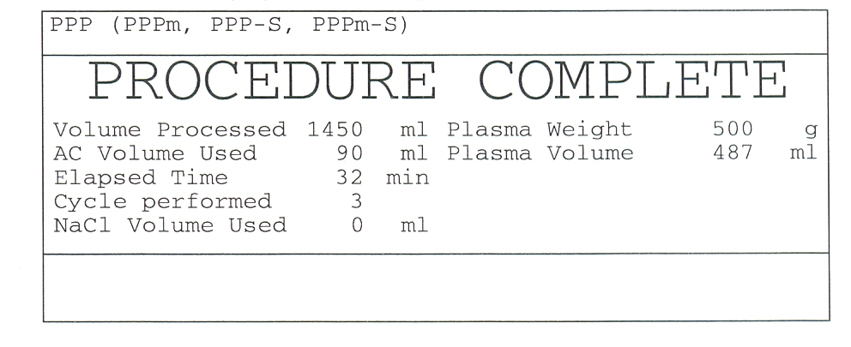

- DOCUMENTATION:
During the procedure and after completing the procedure, document in the format and entered in the register.

- REFERENCES:
- Haemonetics MCS + manual + LN 9000 – 220 E plasma protocols PPP and FFP.
- User manual Haemonetics MCS +.

- END OF DOCUMENT.

