Model SOP

Standard Operating Procedure

Name of the facility / activity : Plateletpheresis

SOP no. | Effective Date | Pages | Prepared by | Authorised by
7.1 | 27-11-2000 | 11
Version | Review Period | Date of Review | Reviewed by | Number of copies
VI | 2 years | 01-01-2015 |  | 10
LOCATION : Apheresis Unit
SUBJECT : Single Donor Platelet Apheresis Procedure
FUNCTION : Select to removal of platelet by cell separator machine (Haemonetics MCS +)
DISTRIBUTION: Medical officer
Master File

- SCOPE & APPLICATION:
The selective separation and removal of thrombocytes (platelets) from withdrawn blood and the remainder of the blood then being retransfused into the donor through cell separator is called plateletpheresis. This standard operating procedure applies to apheresis procedure using the haemonetics cell separator MCS Plus machine for single donor platelet collection.

- RESPONSIBILITY:
It is the responsibility of the trained Staff Nurse and Technicians to perform the procedure under the supervision of Medical officer.

- MATERIAL REQUIRED
- Equipment
- Haemonetics Cell Separator Machine
- LDP Protocol Card (LN09000-220E/ED Platelet Protocol)
- Platelet Apheresis Kit (Haemonetics)
- BP instrument
- Stethoscope
- Tube Sealer
- Emesis Pan
- Urinal
- Torniqute
- Reagents and solutions
- An adequate quantity of Anti coagulant solution
- Spirit
- Cotton swab
- Band Aid
- Emergency injection and drugs

- PROCEDURE:
The operator’s manual for the haemonetics cell separator and the direction for use with the apheresis kit should be followed at all times.
Terminology: Apheresis is a Greek word meaning “to take away” involve the selective removal of blood components from blood donors / patients. Automated blood processing devices are used for both component preparation and therapeutic application of apheresis. In apheresis instrument centrifugal forces separate blood into component on the basis of difference in density. A measured amount of anti coagulant is added to the whole blood during drawing blood from the donors / patients.
This term can be sub divided into three categories
          - Cytaphresis: Selective removal of cellular component from whole blood. These include Erythrocytes, Thrombocytes, Leucocytes and stem cells.
          - Plasma Apheresis: Selective removal of plasma containing elements refer to as fractional components, such as clotting proteins and immunoglobulins.
          - Platelet Apheresis: Selective removal of platelets from whole blood.

Platelet Apheresis (LDP):
The blood is pumped into the rotating bowl in which layering of component occurs on the basis of the density. The desired fraction like platelets or along with plasma collected in a separated bag and remaining elements are returned to the donor by intermittent flow.
A basic LDP collection procedure cycle consist of following specific phases.
Draw Dwell Surge Return

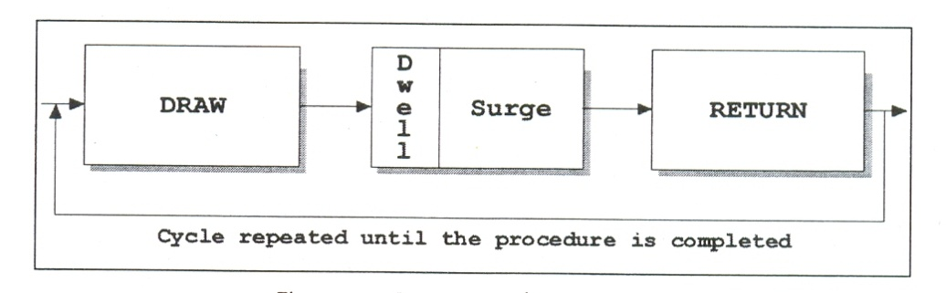
Sequence of an LDP cycle

- Criteria for donor selection for platelet apheresis same as for normal blood donation except
- Written consent on donor card before procedure is commenced and the procedure should be explained to the donor with its benefits and risk.
- The medical officer shall certify that donor is fit for apheresis through donor selection.
- The procedure shall be carried out by a trained person under supervision of a medical officer.
- Platelet pheresis shall not be carried out on donors who had taken medication containing aspirin with in three days prior to donation.
- If during platelet pheresis or luca pheresis RBCs can not be retransfused than at least 12 week shall elapsed before a second procedure is conducted.
- The quantity of plasma separated from the blood of a donor shall not exceed 500 ml per sitting and once in a fortnight or shall not exceed 1000 ml per month.

- Good venous access for successful phlebotomy as well as return of remaining component of blood to the donor.
- Minimum height and weight for the blood volume of 4 litres.
- CBC performed prior to platelet apheresis.
- TTD test performed prior to platelet apheresis.
- Pre platelet count should be more than 1.5 X 10¹¹.
- Predicted platelet yield (1.5 X 10 ⁵ X 4 Ltrs. > 2.5 x 10¹¹).
- Total blood process shall not be more than total blood volume (ECV should not exceed more than 15%) unless platelet pre count has been done.
- The minimum interval between two procedures should be 48 hrs. and not more than twice in a week and 4 times in a month for the same donor.
- The worksheet for the procedure be kept ready to be filled during each cycle.

- Preparing the MCS+ device
- Insert the LDP protocol card into the open card port (right side panel) until the release tab pops out when the MCS + device is powered off.
- Close the card port door securely.

Power on the MCS+ device.
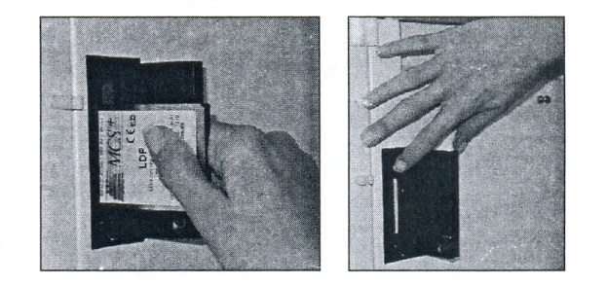
MCS+ protocol insertion and removal

- Immediately after the power on a series of internal self diagnostic test will be conducted prior to each collection procedure.

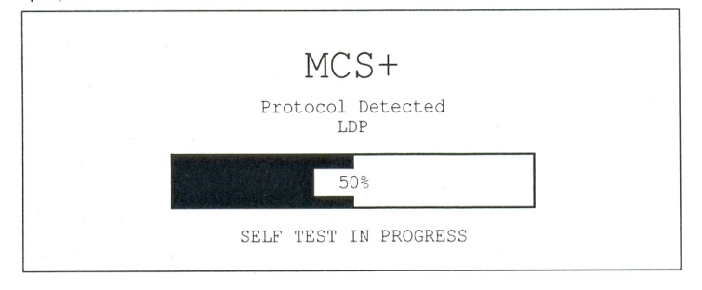
Example of an MCS + diagnostic screen message

Once the self diagnostic test completed the bar graph screen message will indicate 100 %, to confirm that tested system are functioning properly.
- The MCS + device screen will display please lock, unlock and relock the centrifuge lid.

- Selecting protocol Option
When device has performed self diagnostic test the operator will proceed to select certain protocol option.
- Concurrent collection of plasma and platelets.
- Saline compensation.
Protocol option selection menu

Press modify to select yes / no to change option. The selected option will appear highlighted on the screen.

- Disposable set installation
- Extend the weigher arm at 90⁰
- The operator should inspect the disposable material prior to, as well as during installation on the MCS + device using the following guidelines.
- Verify that the disposable set correspond with the selected LDP protocol and options.
- Verify that that neither the packaging kit nor cover has been damaged.
- Inspect all tubing section during installation and insure that no occlusions are present.
- Disposable set installed according to the information display on screen 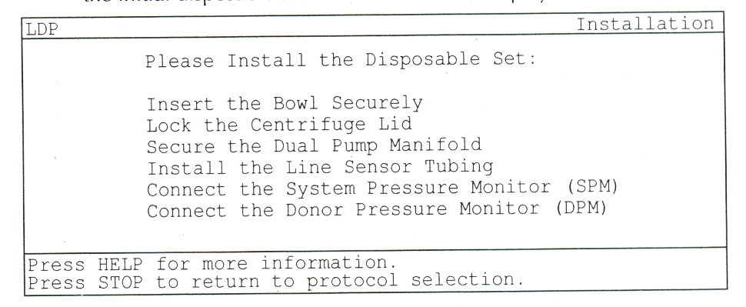
Initial installation screen display

- Autoloading the pumps
After installing the disposable set the device is ready for autoloading the pumps press the draw key to initiate pump tubing autoload.
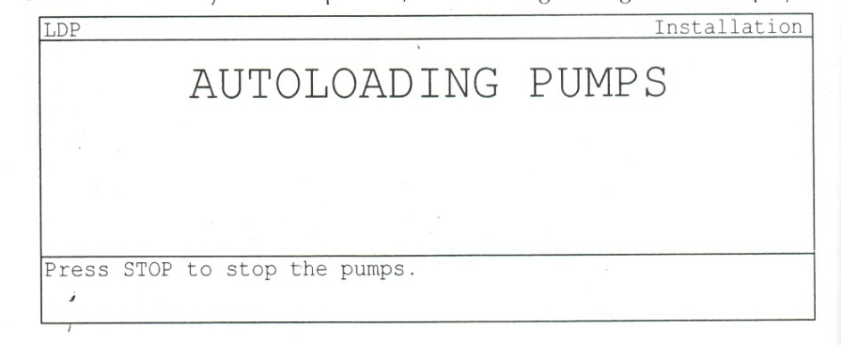
Pump autoload screen display

Once the MCS + pump has been completed the following screen will be display.
Pre-priming screen display

- Priming the LDP disposable set
After autoloding the pumps priming the disposable set immediately prior to performing the donor venipuncture
- Spike the anti coagulant solution bag with the AC spike using aseptic technique.
- Hang the AC bag on the upper hook of the right side of the machine.
- Adjust the height of the pole according to the size of the AC bag used.
- Draw fluid into the AC drip chamber by squeezing it until it is partially filled.
- Press the prime key to initiate the automatic priming sequence.
The following LDP screening message will be display

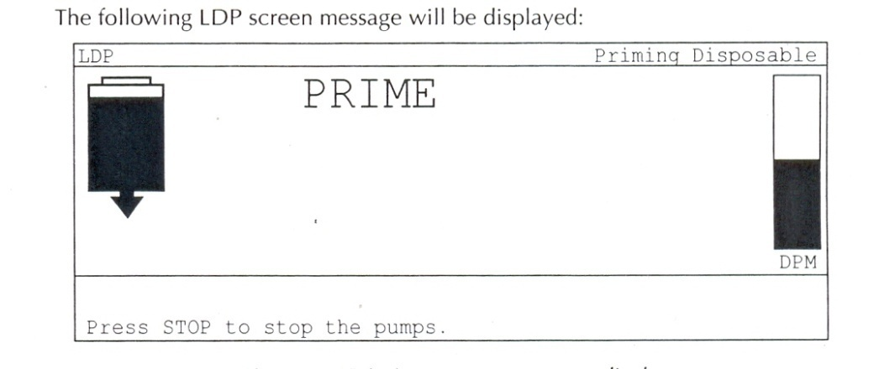
Priming sequence screen display

- Haemocalculator Menu
After priming the disposable kit the Haemocalculator parameter will appear on screen. The individual donor parameter are entered according to certain collection target like platelet yield, volume processed & number of cycle & procedure duration:
- Sex is the gender of the donor expressed as Female (F) or Male (M)
- Height is the height of the donor expressed in centimetres.
- Weight expressed in kilogram.
- Blood volume is the estimated total volume of the donor automatically calculated by the hemocalculator, based on the donor characterstics.
- HCT is the Hematocrit of the donor as determined by a pre-procedure blood sample, expressed as a percentage.
- Platelet Pre–Count is the amount of platelets contained in a specific quantity of donor whole blood.

- Adjusting the Haemo Calculator Menu
To enter the donor and procedure parameters for the current LDP collection procedure the operator should
- Press the modify key to scroll through the parameter list.
- Press the + and – key increase and decrease the values.
- Press the save to retain modify value in the MCS + memory.

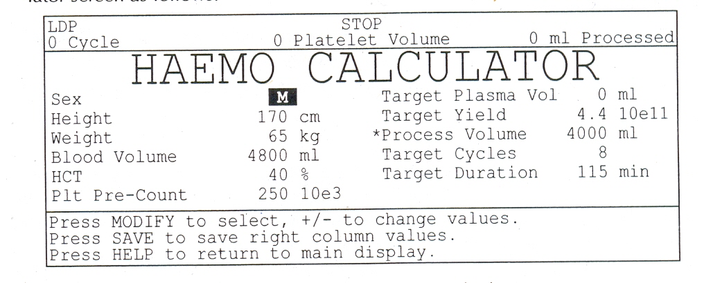
Example of the Haemo Calculator menu

After completion of entering the hemocalutator data screen will display the ready state to indicate to start first draw cycle.
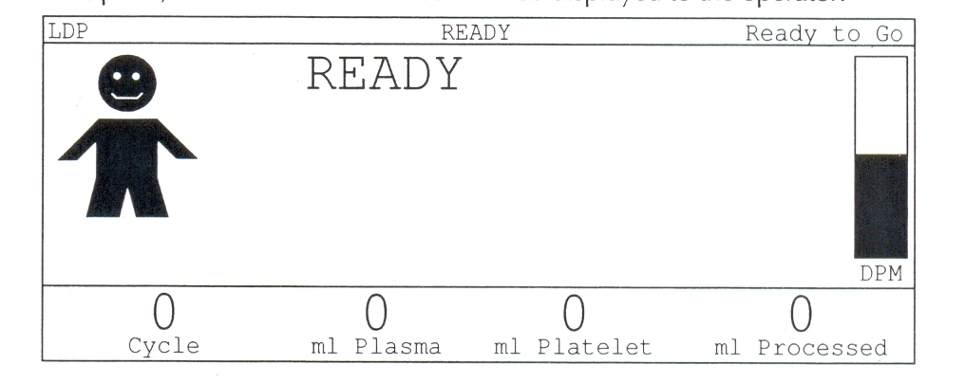
Example of the READY mode screen display

Clean and perform the selected veni puncture side of the donor by using aseptic technique.
Unclamp the donor line and allow blood to flow into the bowl.
Press the draw key to initiate the first collection cycle.
In between the cycle donor should be observed for any symtoms of Hypocalcimia (Perioral numbness and tingling) and should be offered calcium sandoz as placebo.

Draw will contain the following phases

Filling the bowl

Air/plasma interface

Collecting plasma

Transferring plasma

Bowl optics reference

Lines sensor reference

Optic volume

Dwell

Surge

Collecting platelets

- Return Mode
The blood volume drawn during draw cycle will be return back to donor along with plasma.
Once the selected end of procedure criterian have been met the screen will be displayed procedure completed and a beep will be heard. After ending the procedure seal and disconnect the platelet bag and label them.
- Remove the needle from the phlebotomy site and apply pressure dressing and release the donor for refreshment.
- After ending the procedure seal and disconnect the platelet bag from the disposable set and label it.
- Remove disposables and dispose according to policy.
- Note down all the parameters as mentioned on the screen at the end of the procedure.

- DOCUMENTATION:
During the procedure and after completing the procedure, document in the format and entered in the register.

- REFERENCES:
- Manual of the Haemonetics MCS + LDP Platelet Protocol,
- User manual Haemonetics MCS +.

- END OF DOCUMENT.

